About Chartered Professional Accountants of Canada (CPA Canada) 关于加拿大特许专业会计师协会
Chartered Professional Accountants of Canada (CPA Canada) is one of the largest national accounting organizations in the world and is a respected voice in the business, government, education and non-profit sectors.
加拿大特许专业会计师协会（以下简称CPA Canada）是世界上最大的国家级会计组织之一，在商业、政府、教育和非营利领域拥有受人尊敬的发言权。

CPA Canada is a progressive and forward-thinking organization whose members bring a convergence of shared values, diverse business skills and exceptional talents to the accounting field. Globally, it works together with the International Federation of Accountants (IFAC) and the Global Accounting Alliance (GAA) to build a stronger accounting profession worldwide. Within IFAC, only CPA Canada develops and provides professional education courses and programs.
CPA Canada是一个领先和具有前瞻性的组织，其成员为会计领域带来了共同的价值观、多样化的业务技能和卓越的才能。在全球范围内，它和国际会计师联合会（IFAC）和全球会计联盟（GAA）合作，在全世界建立更强大的会计行业。在国际会计师联合会（IFAC）170多家成员协会中，只有CPA Canada自主开发并向其学员提供会计基础教育和专业教育课程。

A COMMITMENT TO EXCELLENCE追求卓越
CPA Canada is dedicated to continual improvement and building a high-performing, innovative organization that creates value for members and other stakeholders.
CPA Canada致力于持续改进并建立一个高绩效、创新的组织，为成员和其他利益相关者创造价值。

Why CPA? 为什么选择CPA Canada？
CPA Canada is THE preeminent, globally recognized and respected accounting and business association.
全球认可和尊重！
If you’re looking to enter the world of business or finance, you’ll need the professional accounting credential that will open doors and enhance your prospects.
如果你想进入商业或金融领域，你需要专业的会计履历来打开这扇大门，同时提升你的前途。
Becoming a CPA student is a wise decision. While stereotypes still exist framing accounting as dull and overly precise, the fact is that Canadian CPAs are well-paid professionals who are in demand around the world. They are CEOs, board members, management consultants and more—and are critical to the success of any business or organization.
成为加拿大CPA学员是一个明智的决定。虽然将会计视为枯燥和过于精确的陈旧观念仍然存在，但事实是，加拿大CPA会员是世界各地需求的专业人士。他们是首席执行官、董事会成员、管理顾问等，对任何企业或组织的成功都至关重要。

Demand紧缺人才
Highly qualified professionals in the accounting, business and finance field will always be in demand. With a Canadian CPA designation, you can be sure that you’re trained to meet Canadian and international market needs and that there is always room to grow.
会计、商业和金融领域的高素质专业人才总是很紧缺。拥有加拿大CPA认证，可以确保你接受过满足加拿大和国际市场需求的培训，并且始终有保持持续进步。

Growth 成长机会
The CPA designation can take you from the beginning of your career to the top position in any type of organization, in any sector of the economy. Along with comprehensive financial management skills, a CPA designation provides you with the soft skills that can make you an effective senior executive.
CPA Canada可以带你从职业生涯的开始到任何经济部门、任何组织机构的最高职位。除了全面的财务管理技能，CPA Canada提供给学员的软技能培养，可以使你成为一个高效的高级行政人员。

How to Become a CPA? 如何成为加拿大CPA？
STEP 1 Complete CPA Canada undergraduate courses and a bachelor degree.
STEP 2 Complete CPA Professional Education Program.
STEP 3 Put your skills to work at employers in any industry sectors (30 months).
STEP 4 Pass CPA Canada Common Final Examination (CFE).
第1步 完成加拿大CPA本科课程并取得学士学位。
第2步 完成加拿大CPA专业教育项目。
第3步 选择任何一个行业的雇主，将你的技能应用于工作中（30 个月）。
第4步 通过加拿大CPA的综合认证考试（CFE）。
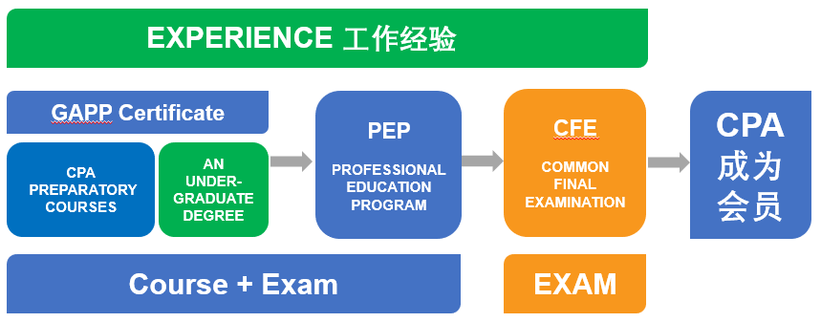

CPA Canada Undergraduate Courses: Recognized Knowledge and Skills
CPA Canada本科阶段课程：取得被认可的知识和技能
The Undergraduate program is an important part of CPA Canada's educational requirements, where students to learn technical knowledge and to improve enabling skills, preparing young people drawn to accounting profession to meet the future with confidence.
本科阶段课程是CPA Canada项目教育要求的重要部分，学生在此阶段完成专业知识的学习、软性技能的提升，让被会计行业吸引的年轻人有信心迎接未来。
There are 14 CPA undergraduate courses, using the latest international course materials (IFRS) and CPA Canada Student Notes, staying in sync with Canadian accounting undergraduates. Students can learn about the learning priorities and difficulties of each course in CPA Canada Student Notes, complete the learning objectives of each course, and ensure that students can take into account both the academic requirements and the practical applications of the accounting profession.
CPA Canada本科阶段专业课程共14门，每门课程使用最新国际版教材（国际会计准则）和每年更新的CPA Canada学习指导教材（Student Notes），与加拿大会计专业本科学生保持同步。学生可以在CPA Canada 指导教材中了解到每门课程的学习重点和难点，完成每门课程的学习目标，确保学生同时兼顾会计学科的学术要求和会计行业的实务应用。
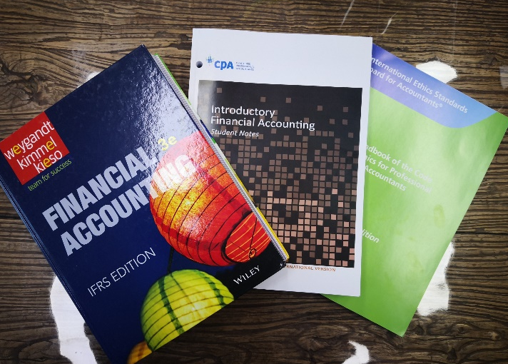
第一门初级财务会计教材

In September 2019, CPA Canada launched the GAPP (Globalized Accounting Professional Program) Certificate, which can be obtained by students who complete 14 CPA undergraduate courses and meet English language requirements (e.g. TOEFL>=80 or IELTS>=6.5 etc.).
2019年9月，CPA Canada推出全球会计专业证书，完成CPA Canada本科阶段的14门课程，满足英语语言要求（比如托福>=80，或雅思>=6.5等）（TOEFL>=80 / ELTS>=6.5））的在校生即可以取得该证书。
With the GAPP Certificate, students will: understand business management issues, acquire a strategic and analytical vision and develop your leadership skills:
取得GAPP证书，学生将了解企业管理问题，获得战略和分析眼光，发展自身的领导力，包括：
Analyze the financial statements of small and large companies
分析小型、大型公司财务报表
Optimize the human and financial resources of organizations
优化组织的人力和财力资源
Assess the impact of a decision on overall performance
评估决策对整体绩效的影响
Advise executives on the right financial approach
就正确的财务方法向高管提供建议
Lead diverse and multidisciplinary teams
领导多元化和多学科团队
Start your own business
自主创业

